# Acknowledgement

We are extremely grateful and remain indebted to Indicus Software leads by SHILPA VYAPARI, for giving us the opportunity to spend 4 months of training in the company. We are thankful to them specially Mr ASEEM, for their constant constructive criticism and invaluable suggestions, which benefited us a lot while developing the project on “ONLINE BUSINESS MANAGEMENT”. Mr ASEEM has been a constant source of inspiration and motivation for hard work. He has been very co-operative throughout this project work. Through this column, it would be our utmost pleasure to express our warm thanks to him for his encouragement, co-operation and consent without which we mightn’t be able to accomplish this project.

           We also express our gratitude to Mr PRASHANT for providing us his availability to carry out the project and to all staff members who were directly and indirectly instrument in enabling us to stay committed for the project.

# Abstract

The project of “ONLINE BUSINESS MANAGEMENT” will create an online platform which will allows business people to manage their activities at anytime and anywhere. This project is more concerned by business of article, in which the owner could manage his items by creating stock with article already registered on his profile. The platform offers also the facility of holding the accounting of that business.

# TABLE OF CONTENT

Acknowledgement 1

Abstract 2

TABLE OF CONTENT 3

LIST OF FIGURE 4

LIST OF TABLE 5

Chapter 1: Introduction 6

1.1 Project purpose 6

1.2 Project scope 6

1.3 Project objectives 6

1.4 Project goal 7

Chapter 2: System Requirement Specifications and Implementation 8

1. Requirement Specifications 8

1.1 Scope 8

1.2 objective 8

1.3 Project description 9

1.4 List of pages 9

1.5 Users path 10

2. Implementation 11

2.1 Tools / environment 11

2.2 Library 11

2.3 Database 13

1.9 Project attributes 16

1.10 building 17

Chapter 3: RESULT 23

CONCLUSION 29

WEBOGRAPHY 30

APPENDIX 31

# LIST OF FIGURE

*Figure 2.1: User path* 9

Figure 2.2: link bootstrap, materialize CSS 11

Figure 2.3: call JavaScript library in the project 11

*Figure 2.4: Website folder organization* 16

*Figure 2.5: create new file* 17

*Figure 2.6: connect to database* 17

*Figure 2.7: Ajax to PHP* 18

*Figure 2.8: insert into database using php* 19

*Figure* 2.9: Give access to user 20

*Figure 2.10: includes files* 21

*Figure 2.11: log out code* 21

*Figure 3.1: Home page* 22

*Figure 3.4: category, item, stock registration* 24

*Figure 3.8: dashboard - single item charts* 27

# LIST OF TABLE

*Table 2.0.1: category entity* 13

*Table 2.0.2: Item Entity* 13

*Table 2.0.3: Stock Entity* 14

*Table 2.0.4: Billing Entity* 14

*Table 2.0.5: Bill Code Entity* 15

*Table 2.0.6: Flow Entity* 15

*Table 2.0.7: Sub-user Account Entity* 15

*Table 1.8: Note Entity* 16

Chapter 1:

# Introduction

## Project purpose

the purpose of this project is to create a website through which business owners such us item’s business owners can access its information and manage all the adding, updating, deleting the assets and some of its tasks.

The admin owner will have all the right over user profile while some sub-users will get dedicated task.

## 1.2 Project scope

Business is the common activity of all human being. It need facilities to be beneficial to the owner and the main element that anyone want to management easily is the business asset (item). The main unfortunate remark is that people get difficulty to control the flow of their product because of luck of strategy, difficult also for them whenever they are outside of the office, for the product are hosted locally only.

So, with all difficulties that are suffering that business owners, we decide to provide an opportunity which will improve their business condition.

In fact, that opportunity is to provide to the business owners the facility to access to their asset (item) at anytime and anywhere, by building an online business management system.

Then, in order to achieve our aim, we will create a dynamic website, so that any business owners particularly product business, can open his account and get access to his own profile in which he will hold all his product, keeps the accounts at anytime and anywhere.

## 1.3 Project objectives

* Create a platform that will allows any subscriber to manage his business online
* The platform provides facility of storing all the article (items) by category in order to create stocks of any article.
* User will do all the movement regarding those stocks and know their status
* The possibility of accounting will be provided and user can manage, bill, order form, delivery form

1.4 Project goal

The main goal of our project is to allow to items business owner to:

* Get well-define management system
* Get reliability on their business
* Be free from dependency of local system

Chapter 2:

# System Requirement Specifications and Implementation

1. Requirement Specifications
   1. Scope

Business is the main activity of all human being. It is the main way to own money. So, the growing of this activity means that its assets are also growing in term of number. The growing of the business asset will create a need for its management.

There are lot of asset management available nowadays, mostly there are used locally.

Our platform will provide a facility to the business owner to manage their asset at anytime and anywhere. They will be safe from storage problem, because it online aspect.

There project is very useful for item business owners, they will get control over their business easily no matter they are in or out of their office.

* 1. objective
* The website should have a sign-up section, and obviously sign in
* Each business owner is the admin of his profile, and he will have the ability to add sub-users and attribute a specific role.
* The website should provide the facility to register business item by category in order to organize the stocks
* The website should provide information about stocks registered. User should have overview on the flow of his stock.
* The website should provide facility of updating, deleting items
* The website should provide section for accounting including online billing.
* The website should provide chart in order to give details about any item registered.

1.3 Project description

Online business management system is a dynamic website which will provide environment to item’s business owners to host their business online.

After creating an account on the platform, the business owner can register all the items which compose his business and he will get the facility to organize it in term of category. Then the possibility to register a stock will be opened so that he can enter all its stocks in order to control the flow regarding these stocks.

The business owners will get also the facility to follow and manage his accounting and perform some main actions such us online bill printable, delivery form, order form…

User profile is multi-user it means that business owners can create sub-users and attribute role to them, then, define which specific action one sub-user can do only.

The platform will also provide a dashboard. This will give an overview on all the activities.

1.4 List of pages

* Home
* About
* Contact us
* Sign in / sign up
* Profile
* User’s company logo
* Items:
* Add category
* Add item
* Stocks:
* Add stock
* Accounting
* Order form
* Delivery order
* Bill
* Dashboard
* Create sub-user

1.5 Users path



**Sign up**

**Sign in**

**User active & access profile**

**Tasks**

**Tasks**

**Sub-users**

**Creates**

**Manages**

**Creates**

*Figure 2.1: User path*

1. Implementation

Implementation is the process of making something active or effective.

Hardware/Software Interface:

This section lists the minimum hardware and software requirements needed to run the system efficiently

Hardware Interface:

* Pentium Processor
* 60 MB of free hard drive space
* 128 MB of RAM

Software Interface:

* Operating System: Windows, Linux, MAC,
* Web Browser: all browser
* Drivers : Java Run-time Environment
* Integrated Development Environment: NETBEAN, PHP

2.1 Tools / environment

* Operating system: available on any system which has a browser
* Programming language: JavaScript, PHP
* Database: MYSQL SERVER, PHPMYADMIN
* Page development tools: HTML, bootstrap, CSS

2.2 Library

A library is a *reusable* piece of code which you use *as it comes*. It does not provide any hooks for you to extend it. A library will usually focus on a single piece of functionality, which you access through an API. You call a library function, it executes some code and then control is returned to your code.

In our project we used two kinds of library:

* Library for designing
* Bootstrap

**Bootstrap** is a free and open-source front-end library for **designing** websites and **web** applications. It contains HTML- and CSS-based **design** templates for typography, forms, buttons, navigation and other interface components, as well as optional JavaScript extensions.

* **Materialize**

**Materialize** UI components help in constructing attractive, consistent, and functional **web** pages and **web** apps, while adhering to modern **web design** principles such as browser portability, device independence, and graceful degradation. It helps in creating faster, beautiful, and responsive **websites**.

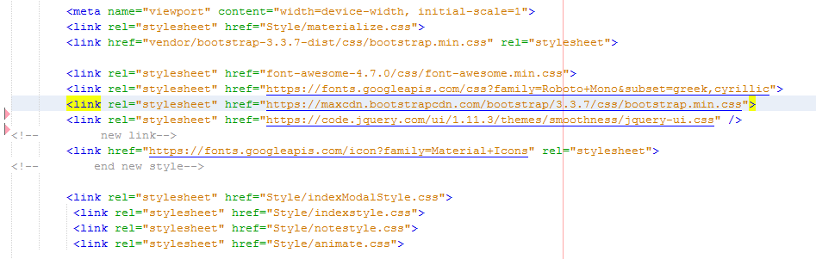

*Figure 2.2: link bootstrap, materialize CSS*

* Library for event handling and animation
* jQuery

**jQuery** is a fast, small, and feature-rich JavaScript **library**. It makes things like HTML document traversal and manipulation, event handling, animation, and Ajax much simpler with an easy-to-use API that works across a multitude of browsers.

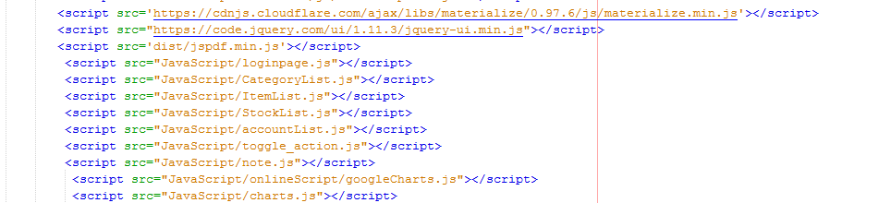

Figure 2.3: call JavaScript library in the project

2.3 Database

A database is a data structure that stores organized information. Most databases contain multiple tables, which may each include several different fields. For example, a company database may include tables for products, employees, and financial records. Each of these tables would have different fields that are relevant to the information stored in the table.

In our project there will be eight (8) tables for each user

* Category table

|  |  |  |
| --- | --- | --- |
| CATEGORY | | |
| S. No | Field Name | Data Type |
| 1 | Id | Auto increment |
| 2 | Category id | Varchar |
| 3 | Category name | Date |

*Table 2.0.1: category entity*

* Items table

|  |  |  |
| --- | --- | --- |
| ITEMS | | |
| S. No | Field Name | Data Type |
| 1 | Id | Auto increment |
| 2 | Item id | Varchar |
| 3 | Item name | Varchar |
| 4 | Category | Varchar |
| 5 | Price | double |

*Table 2.0.2: Item Entity*

* Stocks table

|  |  |  |
| --- | --- | --- |
| STOCKS | | |
| S. No | Field Name | Data Type |
| 1 | Id | Auto increment |
| 2 | Stock id | Varchar |
| 3 | Stock name | Varchar |
| 4 | Number of item | Integer |
| 5 | Entry date | date |
| 6 | Actual item’s number | integer |
| 7 | Last date of update | Date |

*Table 2.0.3: Stock Entity*

* Billing table

|  |  |  |
| --- | --- | --- |
| BILLING | | |
| S. No | Field Name | Data Type |
| 1 | Id | Varchar |
| 2 | Bill id | Varchar |
| 3 | Quantity | Integer |
| 4 | Unit price | Double |
| 5 | Total price | Double |
| 6 | Tax | Double |
| 7 | Discount | Double |
| 8 | Final amount | Double |
| 9 | Item name | Varchar |
| 10 | Date | Date |
| 11 | Customer | Varchar |

*Table 2.0.4: Billing Entity*

* Bill code table

|  |  |  |
| --- | --- | --- |
| BILL CODE | | |
| S. No | Field Name | Data Type |
| 1 | Id | Auto increment |
| 2 | Code | Number |

*Table 2.0.5: Bill Code Entity*

* Flow

|  |  |  |
| --- | --- | --- |
| FLOW | | |
| S. No | Field Name | Data Type |
| 1 | Id | Text (select) |
| 2 | Stock id | Text (select) |
| 3 |  | Date |
| 4 | Duration | Number |
| 5 | Date of return | date |

*Table 2.0.6: Flow Entity*

* User account

|  |  |  |
| --- | --- | --- |
| USER ACCOUNT | | |
| S. No | Field Name | Data Type |
| 1 | Id | Auto increment |
| 2 | Username | Varchar |
| 3 | Password | Varchar |
| 4 | full name | Varchar |
| 5 | Role | Varchar |

*Table 2.0.7: Sub-user Account Entity*

* Note

|  |  |  |
| --- | --- | --- |
| NOTES | | |
| S. No | Field Name | Data Type |
| 1 | Id | Auto increment |
| 2 | Date | Date |
| 3 | Title | Varchar |
| 4 | Content | longText |
| 5 | Reminder | Date |

*Table 1.8: Note Entity*

### 1.9 Project attributes

* Reliability

The website is designed to have a database which will save the business flow of users and they could access it anytime.

* Availability

The website is available as long as the user has internet access on his computer.

* Security

User will get access to his profile only by providing true password and username.

* Maintainability

There will be periodic maintenance on the website to make it more flexible and fast

* Portability

As Internet is requirement for accessing profile, user get access to his profile anywhere.

### 1.10 building

The development platform is NETBEAN which includes PHP, HTML, and JAVASCRIPT …

For the well organization of our source code, we will create script folder, connection db. folder, style folder, includes file folder

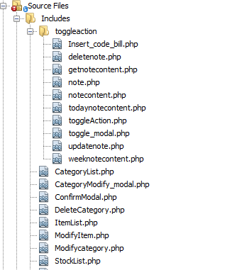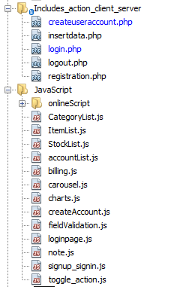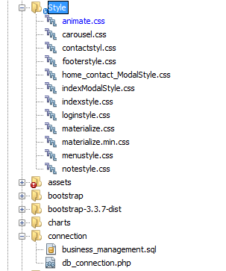

*Figure 2.4: Website folder organization*

* Create new file

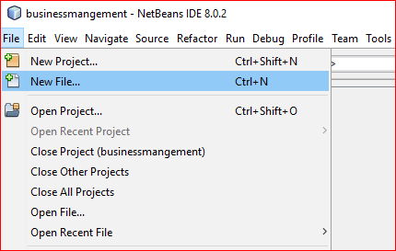

Click on file, then new file. We will get below screen

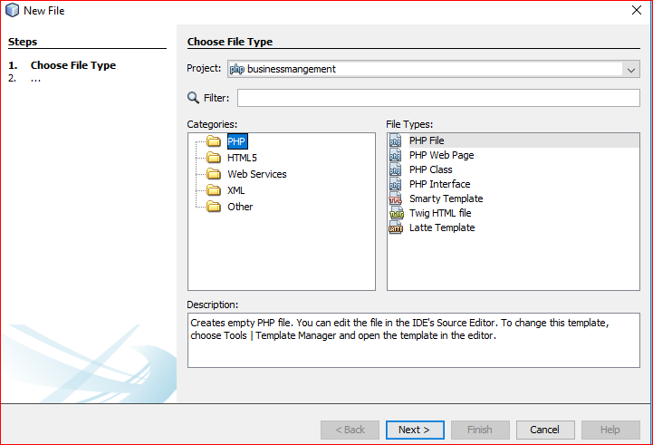

1

2

3

*Figure 2.5: create new file*

1

Project in which you want to add new file

2

Chose the programming language in which you are going to create your file

3

Chose file type

* Connection to database

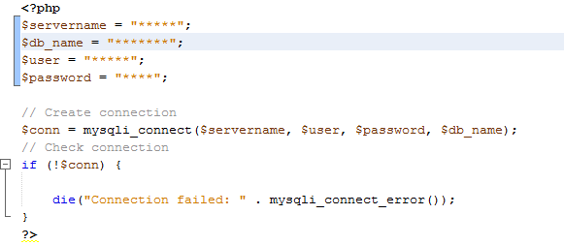

1

2

3

*Figure 2.6: connect to database*

Set server and database information

1

2

Create the connection

3

Check if database and server information are correct, then give the status (get connect or error message

* 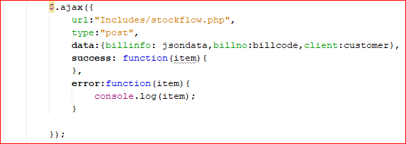Using Ajax

*Figure 2.7: Ajax to PHP*

Ajax is used to send data from page to PHP without refreshing that page or / and to get data from PHP and display the result on page

URL: the link of PHP page to which data will be sent

Type: the type can be post or get method

Data: defines data to send to PHP page

Success: call back from PHP. This can be data to reuse or simple success message

Error: this function allows as the alert or console error from our process

* Insert data into database

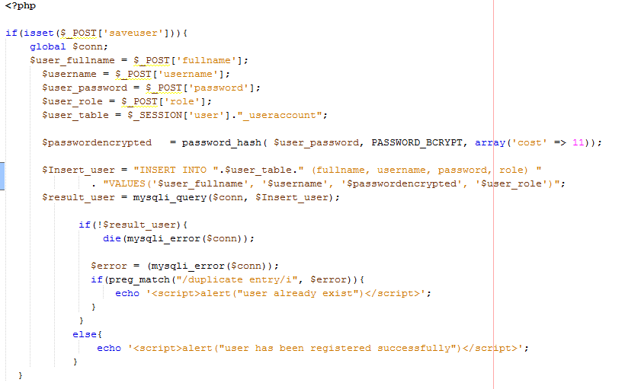

1

2

3

4

5

*Figure 2.8: insert into database using PHP*

1

Get data from html form using post method

2

Encrypt user password before saving into database, so that only user know is password

3

Prepare insert query

4

Execute the query

5

Check if the query executed successfully or not, then display message according the status of result

* Login

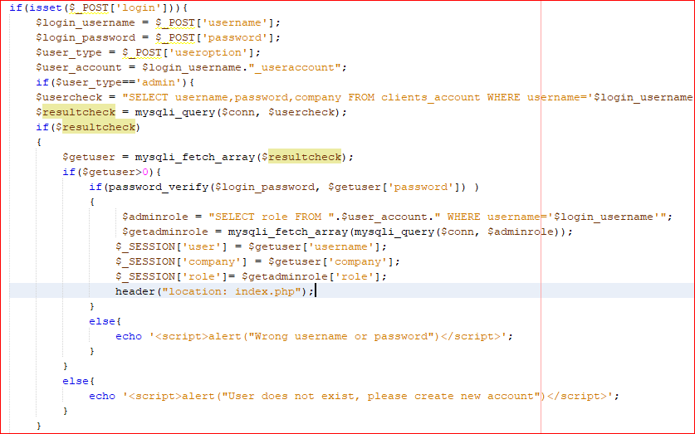

1

2

3

*Figure* 2.9: Give access to user

1

After submitting his authentication data, we will collect it using post method

2

Prepare select query

3

Execute the query, then check if user information match with the information store in the database.

If success, user get connect to his profile. Otherwise he will get message saying that: “informations are wrong or he is not registered yet”.

* 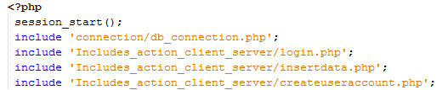Includes files

*Figure 2.10: includes files*

The include keyword is used to call PHP page inside another PHP page. Instead of writing to much code inside a single page, we call use include and this will make our code more readable and easy to debug.

* Logout

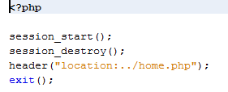

*Figure 2.11: log out code*

This code will destroy user session so that his information will be required to get access to his profile

Chapter 3:

# RESULT

Snapshot of the website:

*Figure 3.1: Home page*

*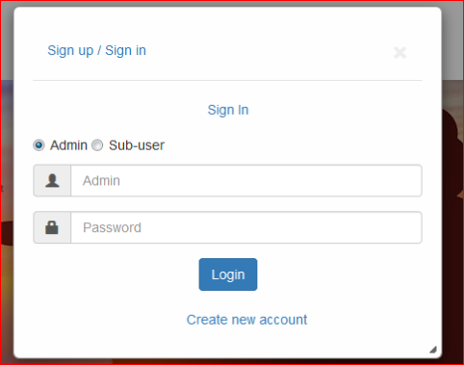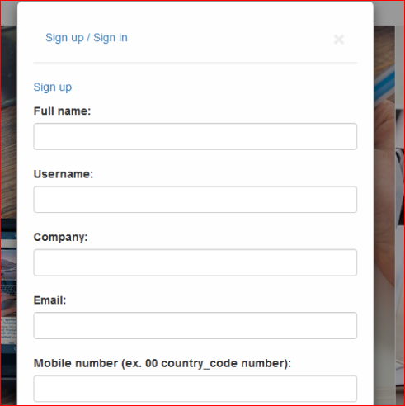Figure 3.2: Sign up*

*Figure 3.3: Sign in*

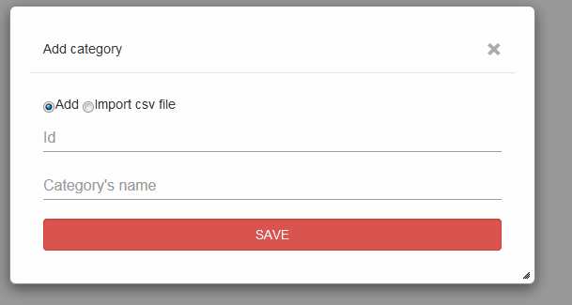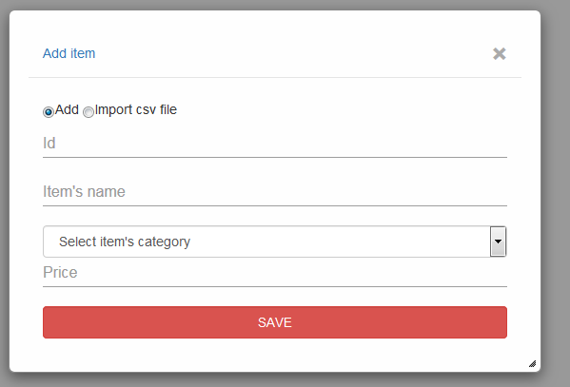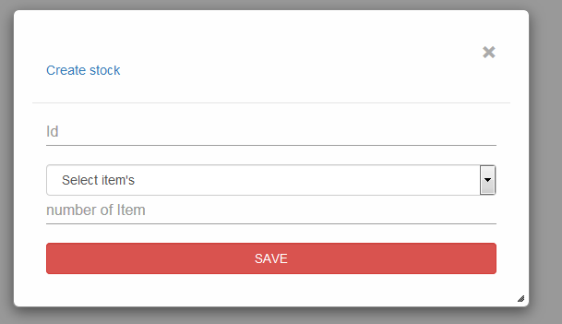

*Figure 3.4: category, item, stock registration*

*Figure 3.5: dashboard - items information*

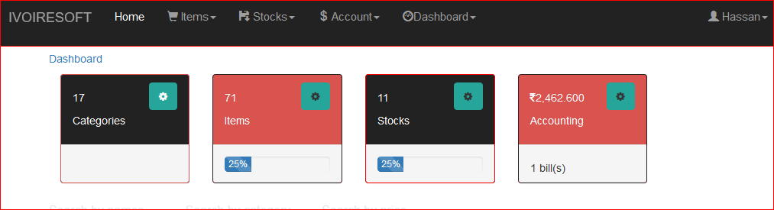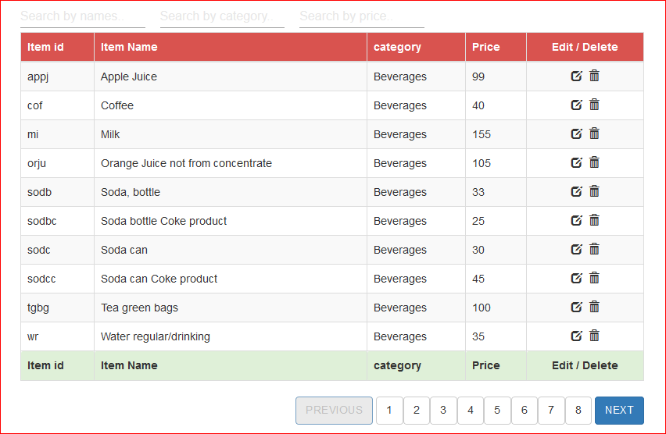

*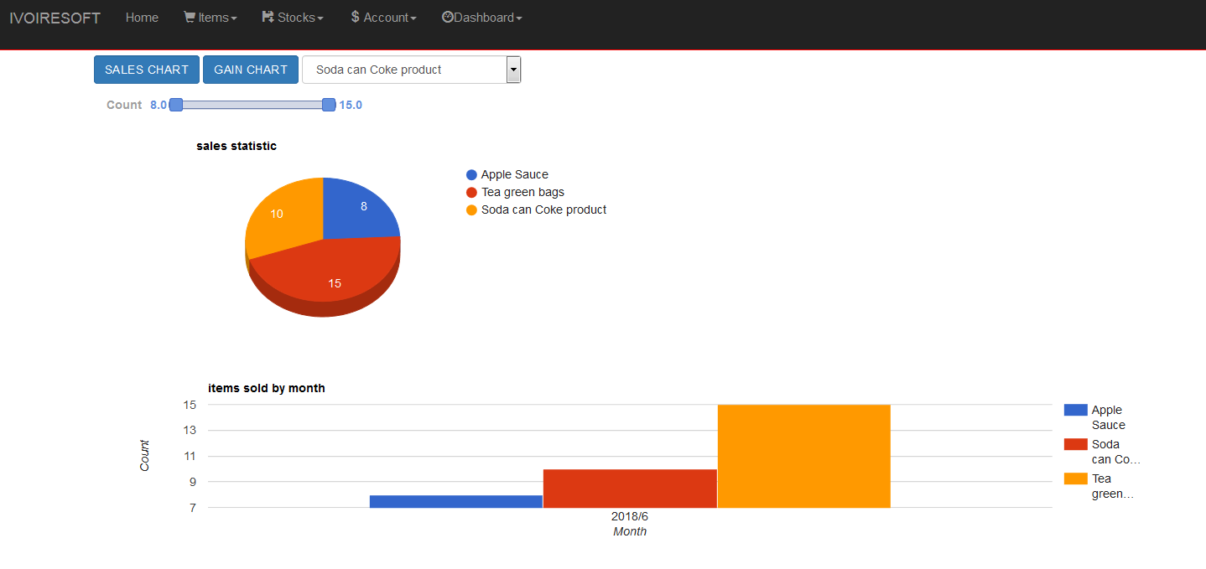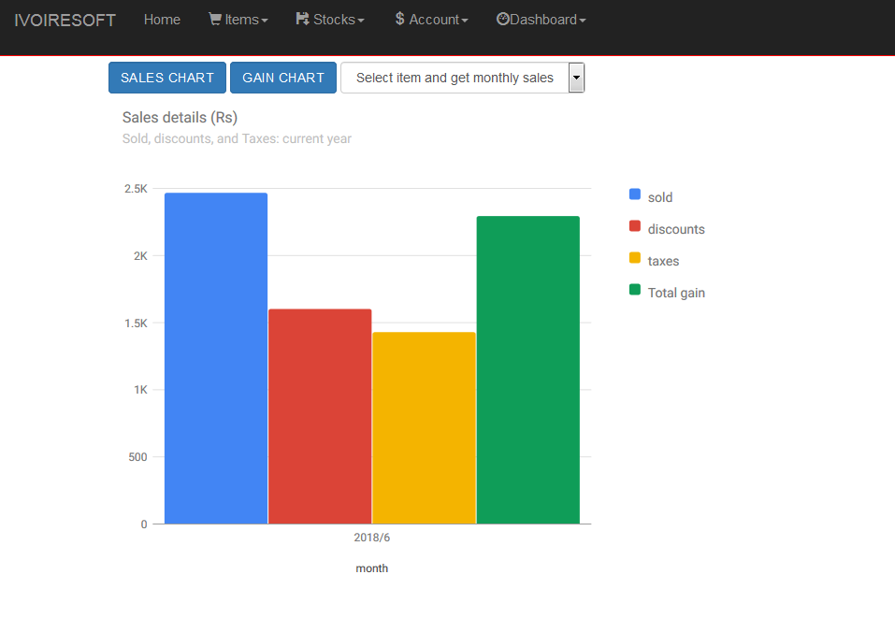Figure 3.6: dashdoard - gain chart*

*Figure 3.7: Dashboard - sales chart*

*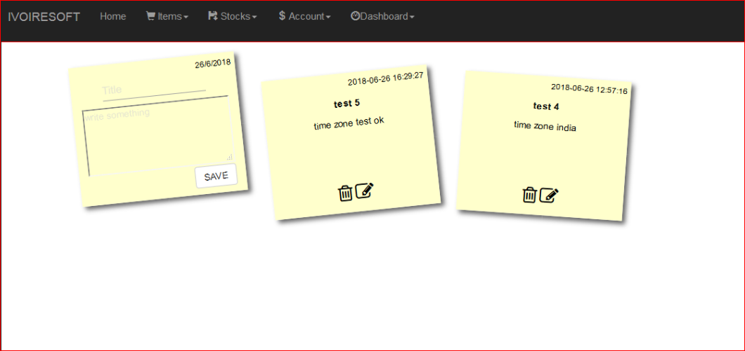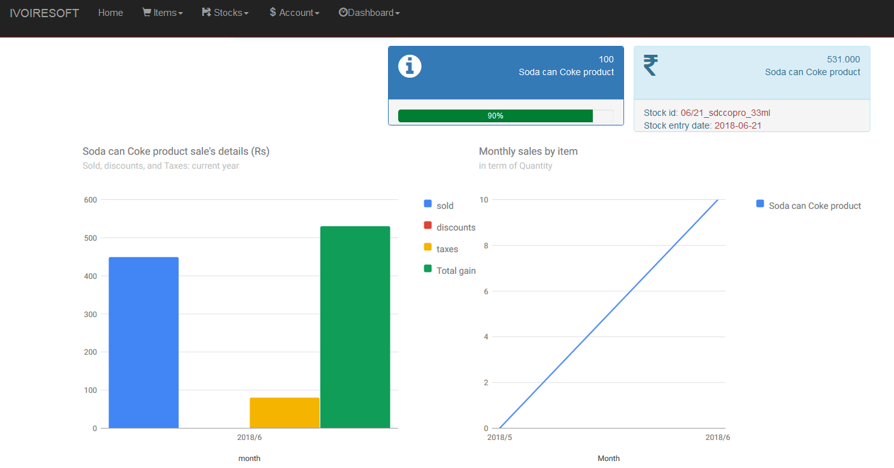Figure 3.8: dashboard - single item charts*

*Figure 3.9: Memo note*

# CONCLUSION

After the implementation of the big part of our website for ONLINE BUSINESS MANAGEMENT, we are sure that project will be very helpful for article business people. This may provide all facility the people to manage their business not only inside their company but at anywhere. It will also resolve a company resource backup problem as all the action of user are going to be saved permanently in a database which will provide sufficient storage to all users.

This website is intended to provide some interesting feature:

* Printable accounting state
* SMS / Email alert
* Implementation of order and delivery form

# WEBOGRAPHY

|  |  |  |
| --- | --- | --- |
| **Website** | **Research** | **Date (month)** |
| www.stackoverflow.com | * MYSQL query * Google chart * JavaScript | May, June |
| www.3wschool.com | * MYSQL issue * Google chart * JavaScript * Bootstrap | April, May, June |
| www.dev.mysql.com | * MYSQL query | May, June |
| www.codepen.io | * Google chart * JavaScript * CSS | April, May, June |

# APPENDIX

